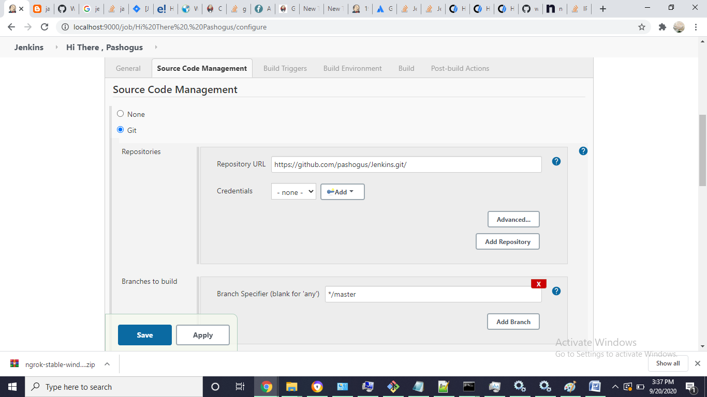

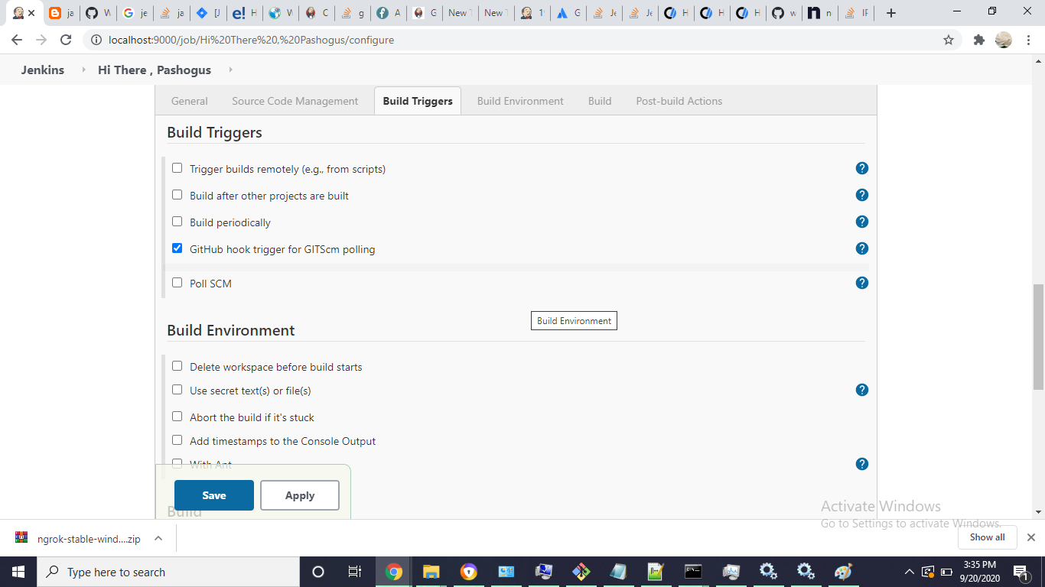

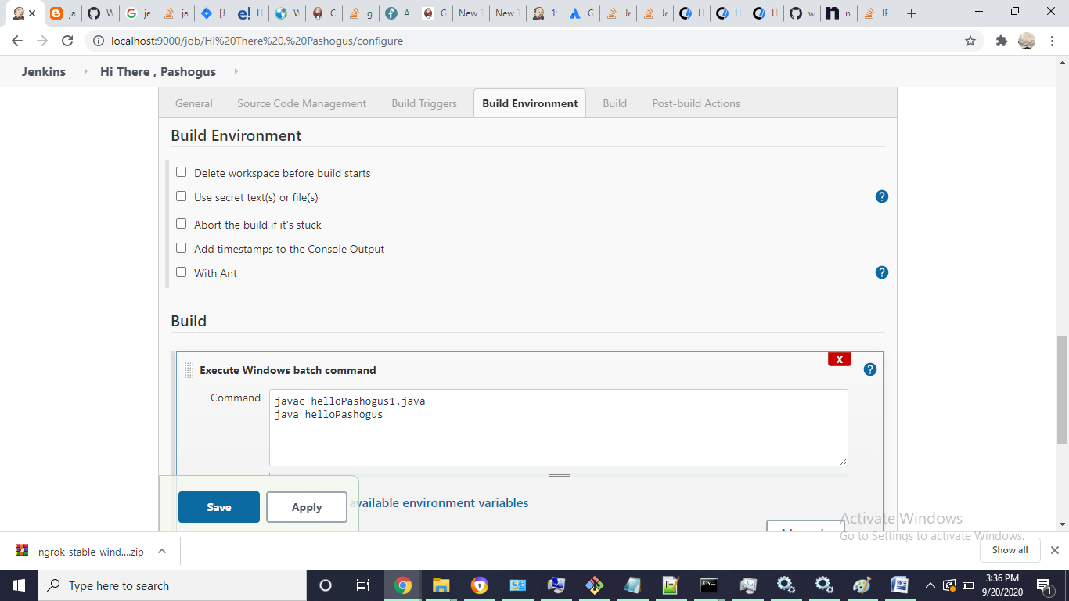

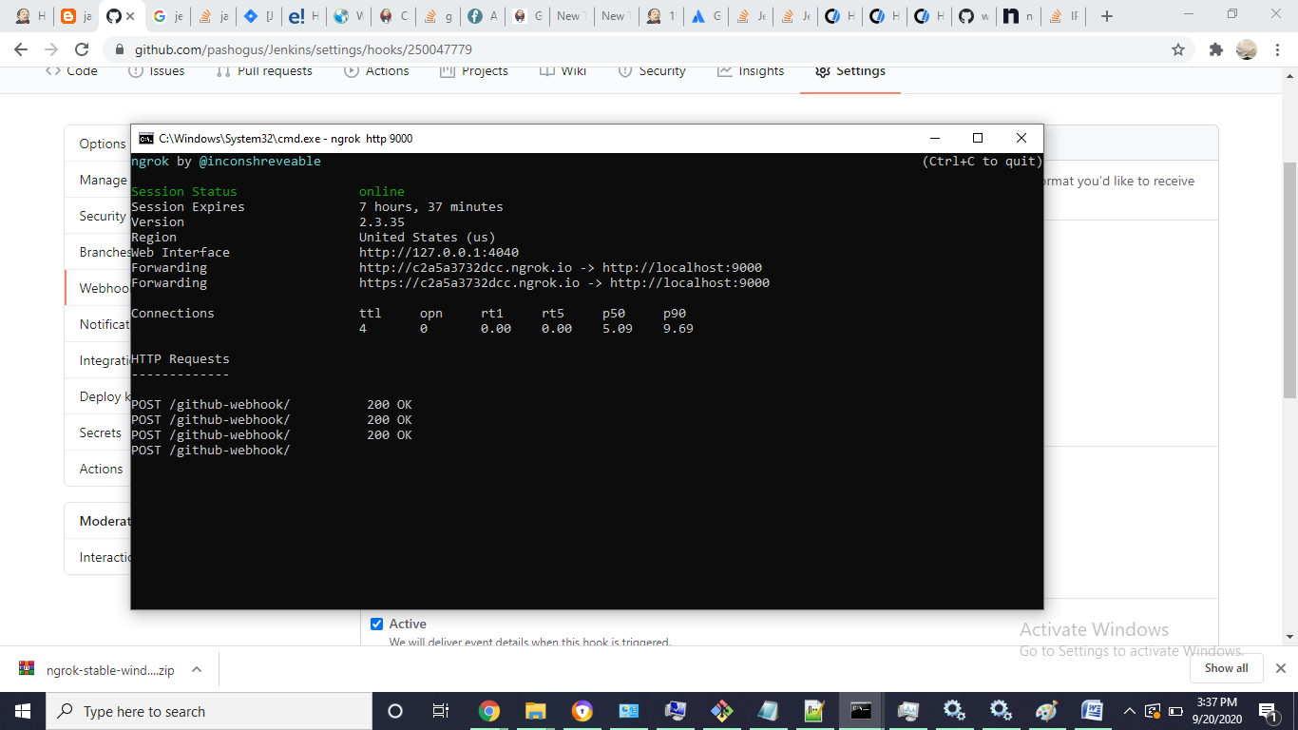

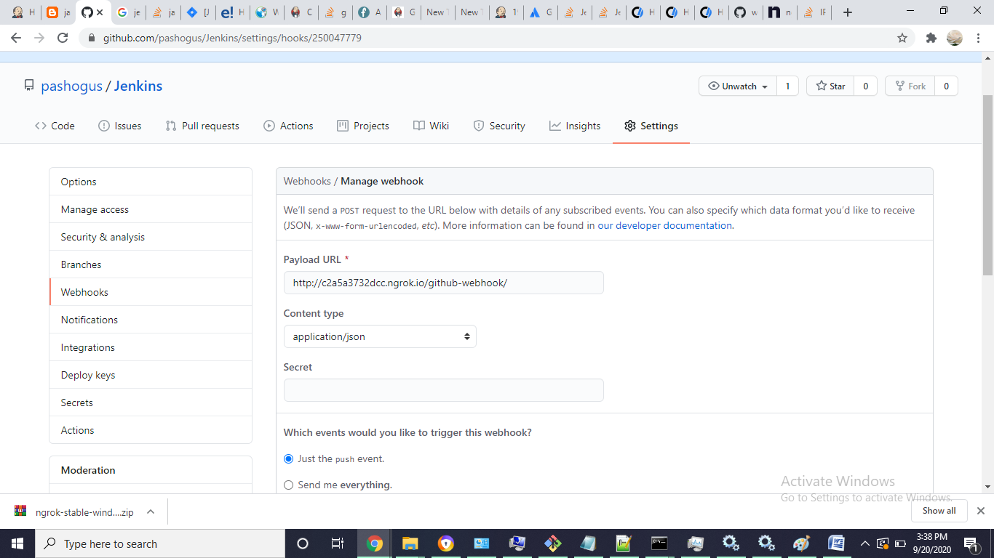

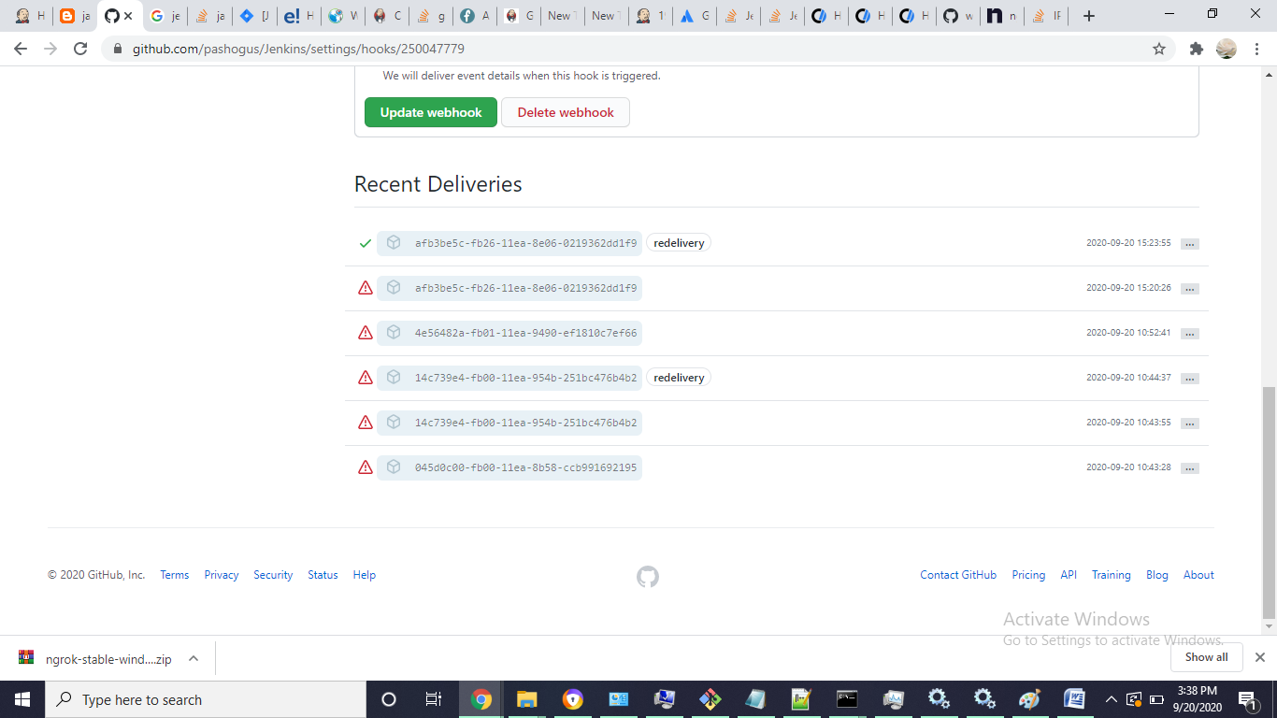

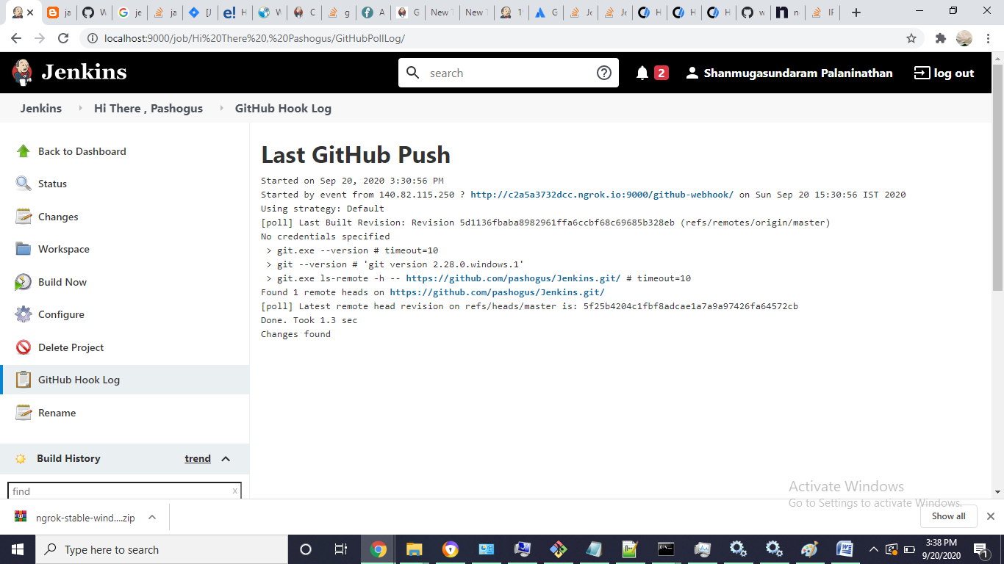

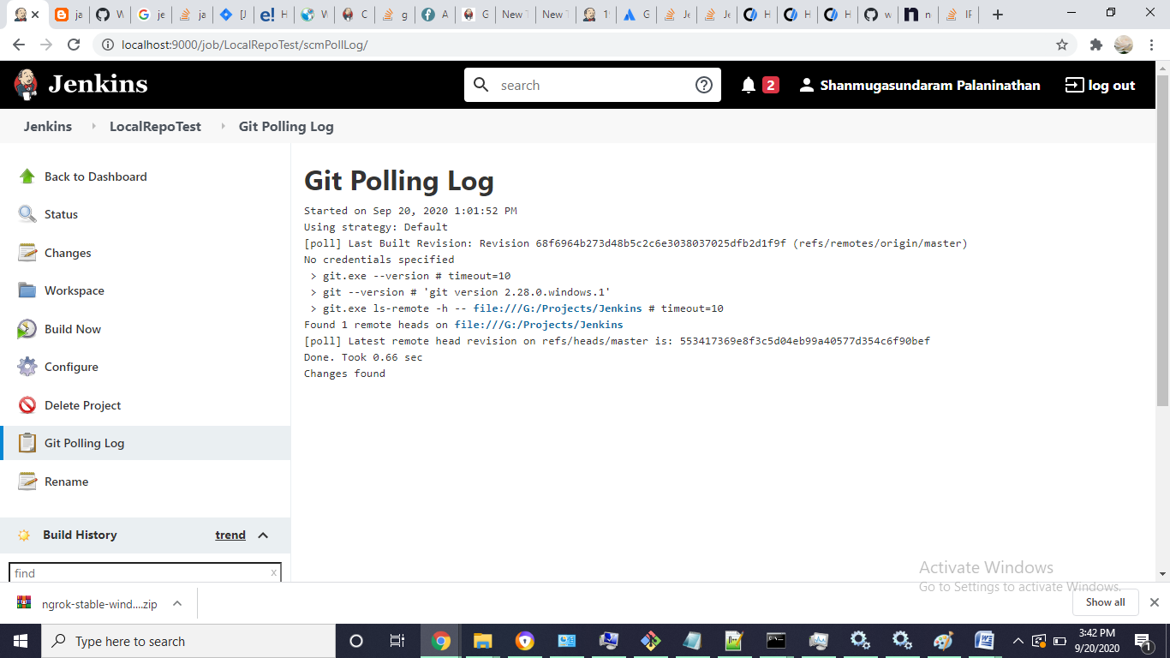

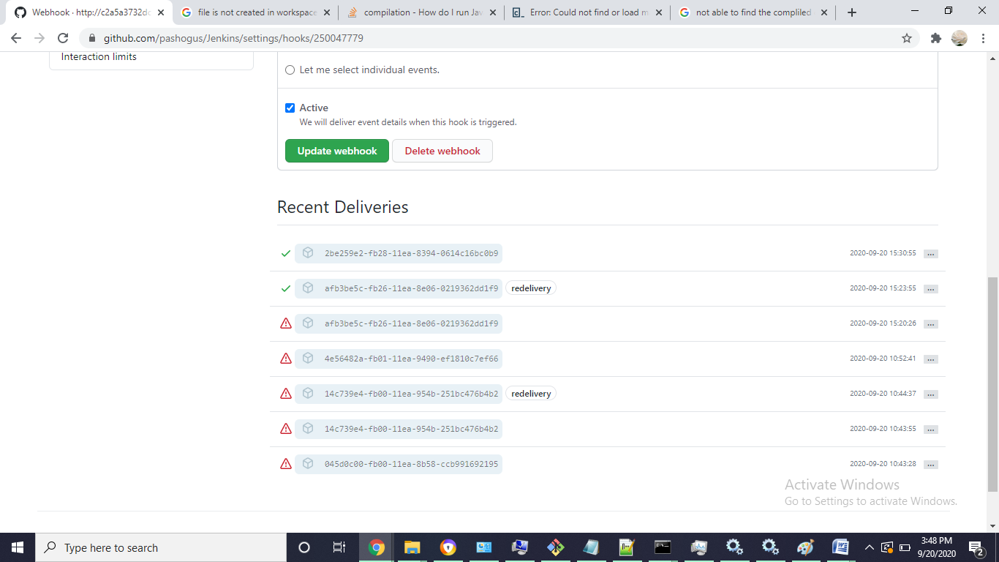

Ref

<http://www.andyfrench.info/2015/03/automatically-triggering-jenkins-build.html>

<https://www.edureka.co/community/49753/auto-build-job-jenkins-there-change-code-github-repository>

<https://www.jenkins.io/doc/book/managing/system-configuration/>

<https://github.com/jenkins-x/jx/issues/5633>

<https://ngrok.com/download>